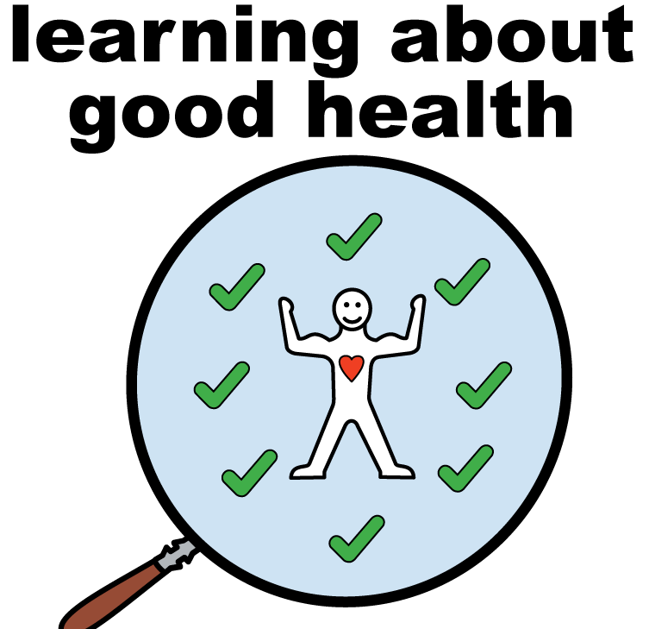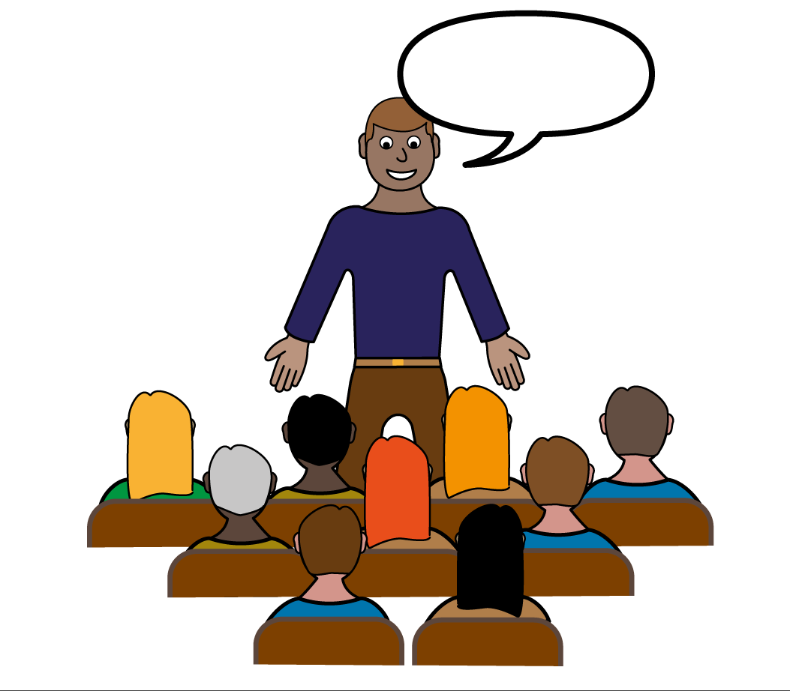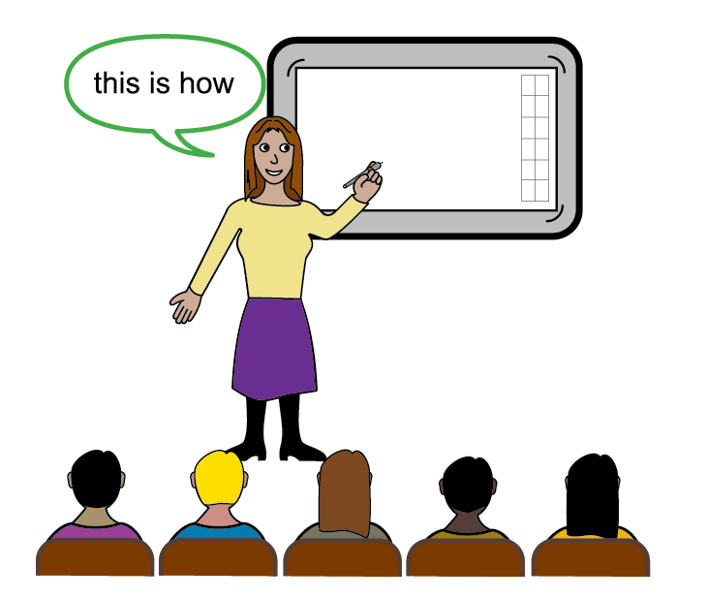
ATTENTION!!
Do you have a Learning Disability?
Are You a Family Carer for Someone aged over 18 with a Learning Disability*?
Are You a Care Worker supporting People with Learning Disabilities in Residential or Supported Living Services*?

Surrey and Borders Partnership NHS Trust Primary Care Liaison Nursing Team are hosting a range of FREE Virtual Learning Disability Events, please see details below:

Learning Disability Services within Surrey and North East Hampshire and Farnham
Wednesday 20th October 12:00-14:00 VIA MICROSOFT TEAMS
https://www.eventbrite.co.uk/e/learning-disability-services-in-surrey-and-north-east-hants-farnham-tickets-156872697461

Physical Health for People with Learning Disabilities Awareness
Wednesday 17th November 12:00-14:00 VIA MICROSOFT TEAMS
https://www.eventbrite.co.uk/e/learning-disabilities-spotlight-event-physical-health-tickets-156875602149

Nutrition for People with Learning Disabilities Awareness
Tuesday 7th December 12:00-13:00 VIA MICROSOFT TEAMS

https://www.eventbrite.co.uk/e/nutrition-for-people-with-learning-disabilities-tickets-156875933139

For Queries, please contact the Primary Care Liaison Nurses on:
Rxx.primaryliaisonld@nhs.net
*Please note: This event is available to people with learning disabilities, families and Care workers across Surrey and North East Hampshire and Farnham.

