The NHS long-term plan explained
On 7 January, the NHS long-term plan (formerly known as the 10-year plan) was published setting out key ambitions for the service over the next 10 years. In this explainer, we set out the main commitments in the plan and provide our view of what they might mean, highlighting the opportunities and challenges for the health and care system as it moves to put the plan into practice.

Contents
- Introduction
- Improving services
Clinical priorities
Primary and community services
Mental health and learning disabilities
Acute services
- Resources
Finance and productivity
Workforce
Digital
Leadership and support for staff
- System priorities
Role of patients and carers
Integrated care and population health
Prevention and health inequalities
- Implementation
- Reflecting on the plan

Introduction
For nearly a decade, the NHS has experienced a significant slowdown in funding growth, while demand for services – and the cost of delivering those services – has grown rapidly. Cuts to public health and social care funding have added further pressure. As a result, NHS performance has declined. Key waiting time targets are being consistently missed and the finances of NHS providers have deteriorated rapidly; in 2017/18, the year-end aggregate provider overspend was £960 million. Workforce shortages are widespread, with more than 100,000 whole-time equivalent staff vacancies in hospitals, including more than 40,000 nurse vacancies. Last year’s winter crisis – the effects of which were still being felt well into the summer – underlined the fragile state of the service.
In June 2018, the Prime Minister announced a new five-year funding settlement for the NHS: a 3.4 per cent average real-terms annual increase in NHS England’s budget between 2019/20 and 2023/24 (a £20.5 billion increase over the period). To unlock this funding, national NHS bodies were asked to develop a long-term plan for the service. The resulting document, the NHS long-term plan, was published on 7 January 2019.
This settlement represents a substantial improvement on the funding growth the NHS has seen since 2009/10, which has averaged approximately 1 per cent a year in real terms. Yet it remains below the average increases of 3.7 per cent a year since the NHS was founded and is less than the 4 per cent annual increases we and others have argued are necessary to meet rising demand and maintain standards of care.
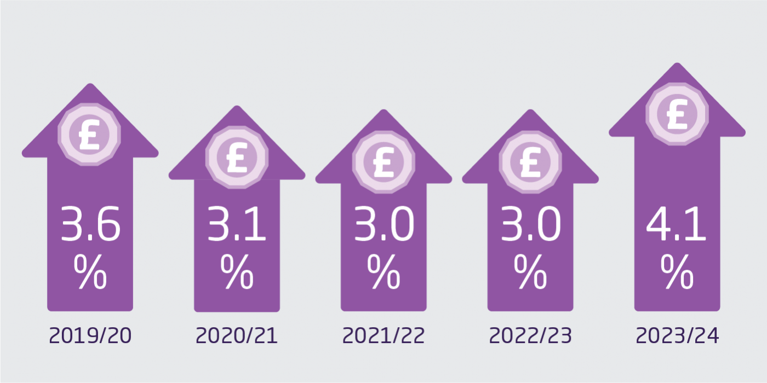
NHS funding 2019/20 to 2023/34
The plan builds on the policy platform laid out in the NHS five year forward view (Forward View) which articulated the need to integrate care to meet the needs of a changing population. This was followed by subsidiary strategies, covering general practice, cancer, mental health and maternity services, while the new models of care outlined in the Forward View have been rolled out through a programme of vanguard sites.
It is important to stress that the funding settlement applies to NHS England’s budget only. This means that some important areas of NHS spending included in the Department of Health and Social Care’s budget – such as capital and education and training – are not covered by it. Local authority public health spending and social care are also excluded. Consequently, it is a plan for the NHS, not the whole health and care system. While it seeks to strengthen the NHS’s contribution in areas such as prevention, population health and health inequalities, the plan is clear that real progress in these areas will also rely on action elsewhere. The Spending Review, which is due to be published later this year and will outline the funding settlement for local government including social care and public health, will therefore have an important impact on whether wider improvements in population health can be delivered, as will the Green Papers on social care and prevention when they are eventually published.

Improving services

Clinical priorities
Perhaps the most striking commitments in the plan relate to a group of clinical priorities, chosen for their impact on the population’s health and where outcomes often lag behind those of other similar advanced health systems. These priorities include cancer, cardiovascular disease, maternity and neonatal health, mental health (see separate section below), stroke, diabetes and respiratory care. There is also a strong focus on children and young people’s health.
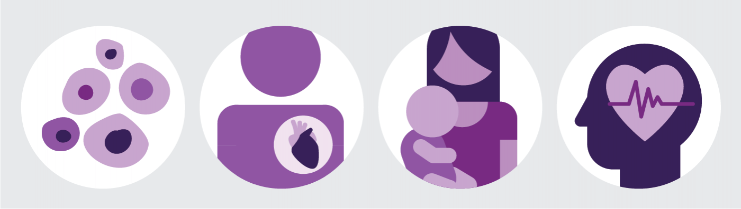
Cancer, cardiovascular disease, maternity and neonatal health, and mental health, are just some of the clinical priorities outlined in the plan.
In cancer care, the plan aims to boost survival by speeding up diagnosis. It includes a package of measures to extend screening and overhaul diagnostic services with the aim of diagnosing 75 per cent of cancers at stages I or II by 2028. A review of cancer screening programmes and diagnostic capacity will also be undertaken to report back in the summer. In 2020, a new waiting time standard will be introduced requiring that most patients get a clear ‘yes’ or ‘no’ diagnosis for suspected cancer within 28 days of referral by a GP or screening.
The maternity and neonatal section builds on the measures being implemented following the National Maternity Review with the aim of halving still births, maternal mortality, neonatal mortality and serious brain injury in newborn babies by 2025. Among a range of commitments, continuity of care during pregnancy, birth and after birth will be improved, bed capacity in intensive neonatal care will increase in areas where this is currently lacking and mental health services and other support for pregnant women and new mothers will be improved.
The plan sets out a number of actions to improve detection and care for people with cardiovascular disease (CVD) and respiratory disease, prevent diabetes and improve stroke services. The aim is to prevent up to 150,000 cases of heart attack, stroke and dementia over the next 10 years. In addition to the focus on maternity and neonatal services, specific commitments are included to improve outcomes for children with cancer, increase support for children with learning disabilities and autism and improve children and young people’s mental health services (see below). A new children and young people’s transformation programme will oversee the delivery of the commitments relating to children and young people.

The King's Fund's view
National leaders deserve credit for targeting measurable improvements in health outcomes and the focus on child health is very welcome. These commitments will save lives and improve the lives of patients but the big question is whether they can be delivered. This will depend on increasing workforce capacity, especially in primary care, investment in diagnostic equipment and clear national leadership. There is also a question about how a change agenda organised around single diseases can be implemented in a way that meets the needs of the growing number of people living with multiple long-term conditions.

Primary and community services
In line with the Forward View and the General practice forward view, improving care outside hospitals is one of the headline commitments in the plan. Encouragingly, the plan backs this goal with money: by 2023/24, funding for primary and community care will be at least £4.5 billion higher than in 2019/20 – ensuring that their share of NHS spending increases over the period.
The plan confirms that general practices will join together to form primary care networks – groups of neighbouring practices typically covering 30–50,000 people. Practices will enter network contracts, alongside their existing contracts, which will include a single fund through which network resources will flow. Primary care networks will be expected to take a proactive approach to managing population health and from 2020/21, will assess the needs of their local population to identify people who would benefit from targeted, proactive support. To incentivise this, a ‘shared savings’ scheme is proposed, under which networks will benefit financially from reductions in accident and emergency (A&E) attendances and hospital admissions. The existing incentive scheme for GPs – the Quality and Outcomes Framework (QOF) – will also see ‘significant changes’ to encourage more personalised care.
There is also a strong emphasis on developing digital services so that within five years, all patients will have the right to access GP consultations via telephone or online. Primary care networks will also roll out the successful approach pioneered by the enhanced health in care homes vanguards so that by 2023/24, all care homes are supported by teams of health care professionals (including named GPs) to provide care to residents and advice to staff.
Alongside primary care networks, the plan commits to developing ‘fully integrated community-based health care’. This will involve developing multidisciplinary teams, including GPs, pharmacists, district nurses, and allied health professionals working across primary care and hospital sites. Over the next five years, all parts of the country will be required to increase capacity in these teams so that crisis response services can meet response times set out in guidelines by the National Institute for Health and Care Excellence (NICE). Access to social prescribing will be extended, with more than 1,000 trained link workers in place by the end of 2020/21.

The King's Fund's view
The continued focus on primary and community services, backed by a clear funding commitment, is very welcome but will be a challenge to deliver. International evidence shows that collaboration in primary care takes time; strong relationships, a shared vision and effective leadership are all crucial. Much rests on primary care networks which are still a relatively untested model. In the coming months, a number of details will need to be clarified and workforce capacity remains a key issue, both in general practice and community services.

Mental health and learning disabilities
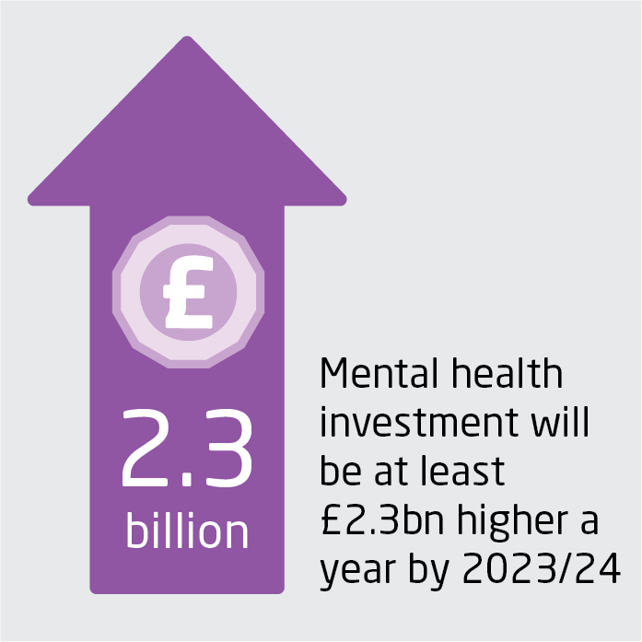
As with primary and community services, national leaders have used the long-term plan to reassert their commitment to improving mental health services, both for adults and for children and young people. This begins with funding: the plan reaffirms that mental health funding – provided through a ring-fenced investment fund – will outstrip total NHS spending growth in each year between 2019/20 and 2023/24 so that by the end of the period, mental health investment will be at least £2.3 billion higher in real terms.
In adult services, the plan signals an extension of commitments in the Five year forward view for mental health beyond 2020/21 to 2023/24. It aims to create a more comprehensive service system – particularly for those seeking help in crisis – with a single point of access for adults and children and 24/7 support with appropriate responses across NHS 111, ambulance and A&E services. It also highlights the need for capital investment, as identified by a recent review of the Mental Health Act, to ensure suitable therapeutic environments for inpatients.
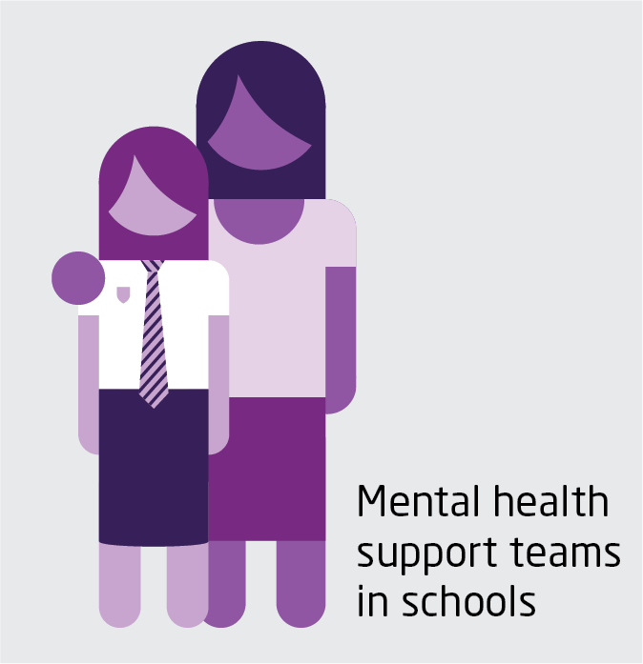
Similarly, the plan commits to a significant expansion of services for children and young people in line with the proposals outlined in the Green Paper on young people’s mental health – for example, the creation of ‘mental health support teams’ in schools. To support these changes, the plan mandates that investment in children and young people’s mental health provision will grow faster than the overall NHS budget and total mental health spending.
There are two significant commitments to developing new models of care. The first is to create a comprehensive offer for children and young people, from birth to age 25, with a view to tackling problems with transitions of care. The second is to redesign core community mental health services by 2023/24, reinforcing components such as psychological therapies, physical health care and employment support, as well as introducing personalised care and restoring substance misuse support within NHS mental health services. These commitments will be backed up by new waiting time standards covering emergency mental health services by 2020, children and young people’s mental health services and, over the next decade, adult community mental health treatment.
There is also a strong focus on improving care for people with learning disabilities and autism. Commitments include increasing access to support for children and young people with an autism diagnosis, developing new models of care to provide care closer to home and investing in intensive, crisis and forensic community support. The aim is that, by 2023/24, inpatient provision for people with learning difficulties or autism will have reduced to less than half of the 2015 level.

The King's Fund's view
The continued commitment to mental health services, and consistency of direction, is positive. Focusing on comprehensive support recognises that mental health services work best when integrated with each other and the wider health and care system. Improving core community mental health services has been neglected in previous plans and represents a significant (although as yet undefined) commitment. Proposals for a funding ring fence reflect ongoing concerns that some funding intended for mental health services may not be reaching the front line. The plan’s focus on acute mental health services in particular will depend on recruiting enough appropriately skilled staff.

Acute services

Urgent and emergency care
The plan includes a significant package of measures aimed at reducing pressures on A&E departments. Many of the measures build on previous initiatives, including the introduction of clinical streaming at the front door to A&E and the roll-out of NHS 111 services across the country.
The plan commits to rolling out urgent treatment centres (UTCs) across the country by 2020 so that urgent care outside hospitals becomes more consistent for patients. UTCs will be GP-led facilities and will include access to some simple diagnostics and offer appointments bookable via NHS 111 for patients who do not need the expertise available at A&E departments. Alongside this, the plan aims to improve the advice available to patients over the phone and extend support for staff in the community by introducing a multidisciplinary clinical assessment service (CAS) as part of the NHS 111 service in 2019/20.
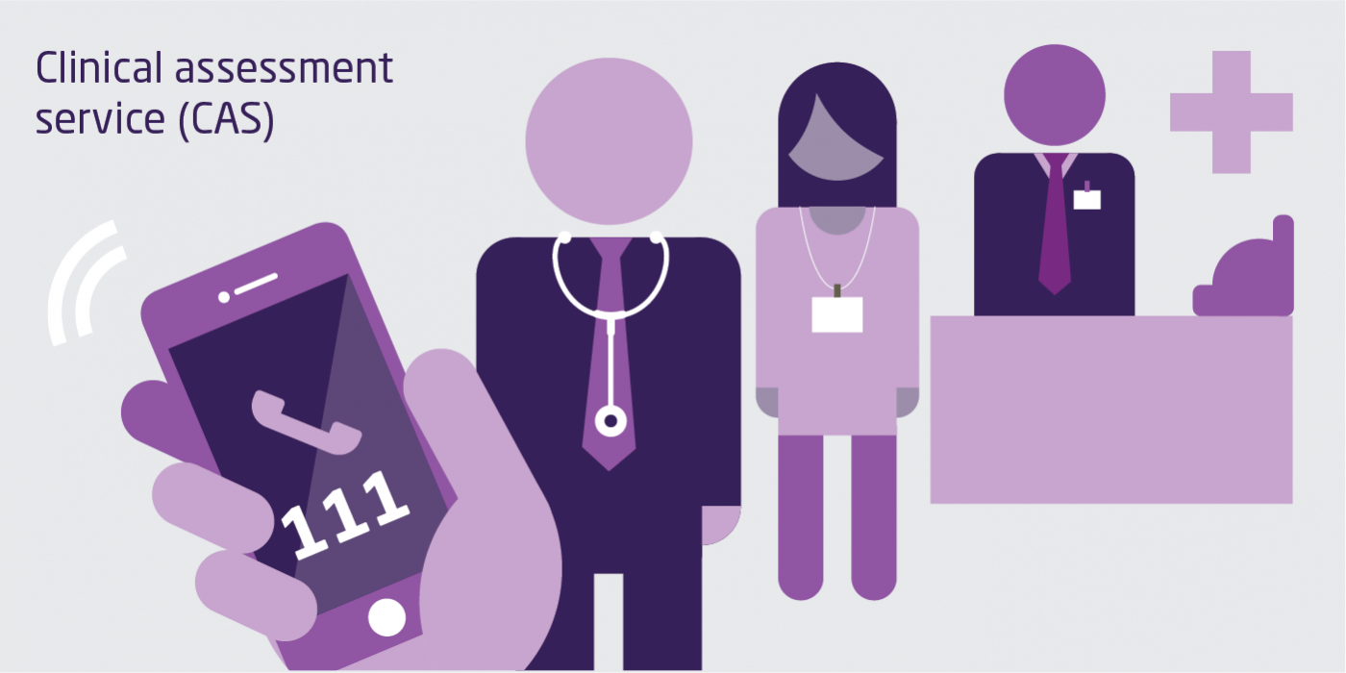
Over the same timeframe, all major A&E departments will introduce same day emergency care (also known as ambulatory emergency care). This will see some patients admitted from A&E undergo diagnosis and treatment in quick succession so that they can be discharged on the same day, rather than staying in hospital overnight. The plan estimates that up to one-third of all people admitted to hospital in an emergency could be discharged on the same day by rolling out this model. Despite ongoing concerns about operational performance in emergency care, the plan does not make any commitment on the four-hour A&E target, postponing any decision to restore performance standards until the Clinical Review of Standards reports in the spring.
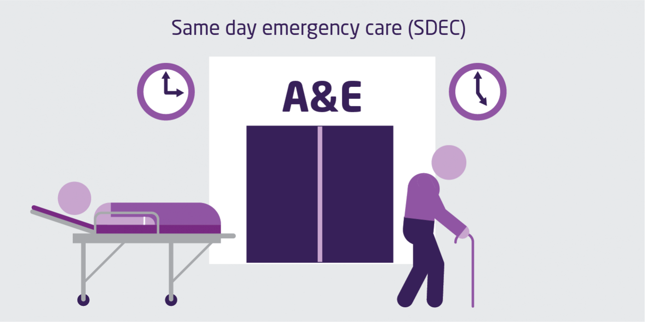
Ambulance services are tasked with implementing the recommendations of a recent review of operational performance led by Lord Carter and will be subject to a new commissioning framework.

Wider acute services
Unlike some previous NHS strategies, the long-term plan does not assume that moves to strengthen primary and community care will reduce demand for inpatient hospital care. Instead, its plans for hospital bed numbers and staffing assume that acute care will grow broadly in line with the past three years (although the plan does not specify what figure it is using for this).
The plan includes an ambitious pledge to use technology to fundamentally redesign outpatient services over five years. The aim is to avert up to a third of face-to-face consultations in order to provide a more convenient service for patients, free up staff time and save £1.1 billion a year if appointments were to continue growing at the current rate. It is not yet clear what this redesign will involve.
Although the plan notes that these changes will have implications for how waiting times performance is calculated, there is no commitment to meet the 92 per cent target for 18-week waits. Instead, over five years, the volume of planned activity will increase year-on-year to reduce long waits and cut the number of people on the waiting list (currently more than 4 million). The commitment to reduce long waits is given teeth by the reintroduction of fines for providers and commissioners where patients wait 12 months or more.
Reducing delayed discharges from hospital remains a priority. The plan aims to cut the average number of daily delayed transfers of care (DTOC beds) to around 4,000 and maintain that level over the next two years before reducing it further (DTOC beds averaged 4,580 in November 2018). Changes to primary and community care may help here, although investment in social care will also be crucial.
The plan signals changes to the configuration of hospital services. NHS Improvement will back hospitals that want to split their services into ‘hot’ and ‘cold’ sites (for emergency and planned work respectively). Trusts will be supported to collaborate to improve services (for example, through provider groups) and, where appropriate, formal mergers will be green-lighted. Further consolidation of specialist stroke services is also signalled and there is a commitment to a standard delivery model for smaller acute hospitals serving rural populations.

The King's Fund's view
The plan is consistent with recent policy in signalling continued change for acute services. The relatively cautious assumptions about demand for inpatient care should avoid a repeat of local plans being predicated on unrealistic reductions in bed numbers. Patients will notice changes to the front door of the urgent care system and to the configuration of hospitals in some places. It remains to be seen whether some of these changes – particularly those that rely on deploying technology – can be delivered and whether they will enable providers to improve performance. Expectations about waiting times will only become clear when the clinical review of standards is published.

Resources

Finance and productivity
Although on current forecasts the NHS as a whole is expected to be in balance in 2018/19, many individual providers and commissioners are struggling to eliminate deficits. When the Prime Minister announced the new funding settlement, she was clear that, over time, all NHS organisations should get back into balance. The penultimate chapter of the plan sets out how this will be achieved.
There are commitments to return the provider sector to balance by 2020/21 and for all NHS organisations (commissioners and providers) to balance by 2023/24. To achieve this, NHS Improvement will deploy an accelerated turnaround process in the 30 worst financially performing trusts and a new financial recovery fund, initially £1.05 billion, will also be created for trusts in deficit who sign up to their control totals. Much of the detail relating to these initiatives is left to the recently published Planning Guidance.
The problems currently being experienced by providers partly reflect flaws in an NHS financial regime that is in desperate need of reform. The measures in the plan – which follow on from changes to the system of central financial support already announced by national NHS bodies – are an effort to address this. They include changes to the payment system to support a shift away from activity-based payments to population-based payments, although this will need to fit with ‘ring-fenced’ funding set aside for primary and community care and mental health services. The plan also proposes changes to the ‘market forces factor’ (an adjustment made to the tariff to reflect the costs of delivering services in different areas), to be phased in over the next five years.
There are a number of measures aimed at supporting delivery of integrated care and incentivising system-based working to improve population health. In 2019/20, as part of the process of moving towards system control totals, sustainability and transformation partnerships (STPs) and integrated care systems (ICSs) will be given more flexibility to agree financially neutral changes to control totals for individual organisations within their systems. From 2019/20 onwards, further reforms will give ICSs greater control over their resources will be introduced, through a process of ‘earned financial autonomy’, to be assessed on the basis of their financial and operational performance. Changes to the commissioning allocations for Clinical Commissioning Groups (CCGs) will support the plan’s focus on tackling health inequalities and better reflect need for mental health and community services.
There is also a focus on ‘getting the most out of taxpayers’ investment’ in the NHS – to be delivered in part through productivity growth of at least 1.1 per cent a year for the next five years. To achieve this, the plan sets out 10 priority areas which largely expand on existing schemes such as erostering, centralised procurement, e-prescribing, stopping low-value treatments, and improving access to information, with the plan suggesting that uptake of these will be on a ‘comply or explain’ basis at board level. The plan also requires the NHS to deliver savings from administrative costs of more than £700 million by 2023/24, with commissioners expected to deliver £290 million and providers £400 million.

The King's Fund's view
After years of deficits and dependence on central funding, many of these measures will be welcomed by NHS providers. If the plan succeeds in getting the majority of trusts into balance, this would be a significant achievement. Changes to CCG allocations to better reflect mental health and community services are also welcome, particularly given the emphasis they receive in other parts of the plan. While efficiency targets will be more realistic than in recent years, it is clear that increasing productivity will continue to be a key priority for NHS organisations.

Workforce
Workforce shortages are currently the biggest challenge facing the health service. The plan explicitly recognises the scale of this challenge and sets out a number of specific measures to address it. However, many wider changes will not be finalised until after the 2019 Spending Review, when the budget for training, education and continuing professional development (CPD) is set. To inform these reforms, NHS Improvement, Health Education England and NHS England will establish a cross-sector national workforce group and publish a workforce implementation plan later in 2019.
For nursing, the aim is to reduce the vacancy rate from 11.6 per cent to 5 per cent by 2028. To achieve this, as well as the previously announced 25 per cent increase in nurse undergraduate placements, the plan commits to funding a 25 per cent increase in clinical nursing placements from 2019/20 and an increase of up to 50 per cent from 2020/21. More accessible routes into nursing will also be introduced, including a new online nursing degree linked to guaranteed clinical placements and continued investment to support an expansion of apprenticeships, with new nursing associates starting in 2019.
The plan reiterates the Department of Health and Social Care’s commitment to increase medical school places from 6,000 to 7,500 per year and suggests that this figure could increase if further funding is provided in the Spending Review. There is also an ambition to shift the balance from specialised to generalist roles in line with the needs of patients with multiple long-term conditions. To support general practice, the intention is to continue to increase the number of other members of the primary care team, such as clinical pharmacists and physiotherapists, although much of the detail on this is again left to the forthcoming workforce implementation plan.
The plan outlines steps to address workforce shortages in the health service.
The plan sets a long-term ambition to train more staff domestically. In the meantime, it emphasises the need for a continued inflow of international recruits. The forthcoming workforce implementation plan will outline new national arrangements to support NHS organisations with overseas recruitment and explore the potential to expand the Medical Training Initiative. The ambition is to deliver a step change in the recruitment of international nurses, increasing the number recruited by ‘several thousand’ each year over the next five years.
The plan recognises the important role that volunteers play in the NHS, committing £2.3 million to Helpforce, which has been charged with scaling capacity for volunteering in the NHS.

The King's Fund's view
The plan correctly diagnoses the problem and the actions it proposes are the right ones. Most of these actions will take time to deliver and much is left to the new national workforce group and forthcoming workforce implementation plan to address. Some action will depend on other government decisions, for example, on the training budget, and the UK’s future immigration policy. In the meantime, however, workforce shortages remain a key risk and the plan is a missed opportunity to have taken urgent action to address this – for example on international recruitment of nurses.

Digital
Digital technology underpins some of the plan’s most ambitious patient-facing targets. The NHS app will act as a gateway for people to access services and information; by 2020/21, people will be able to use it to access their care plan and communications from health professionals. From 2024, patients will have a new ‘right’ to access digital primary care services (eg, online consultations), either via their existing practice or one of the emerging digital-first providers. By the end of the 10-year period covered by the plan, the vision is for people to be increasingly cared for and supported at home using remote monitoring (via wearable devices) and digital tools. Digital technology will also facilitate service transformation, including the redesign of outpatient services and reorganisations of pathology and diagnostic imaging services.
To deliver ‘digitally enabled care’ as envisaged, the plan reiterates the previously stated ambition that all secondary care providers become ‘fully digitised’ by 2024 (a deadline that has slipped from the original target to be ‘paperless’ by 2020). This will involve NHS organisations putting in place electronic records and a range of other digital capabilities. The Global Digital Exemplars programme will admit new organisations and create models for technology adoption and a shared record through Local Health and Care Record Exemplars.
Digital technology underpins some of the plan's most ambitious patient-facing targets.
To facilitate these changes, a number of policies previously announced by the Secretary of State have now become firm commitments. For example, NHS organisations will be required to have a chief clinical information officer or chief information officer at board level by 2021/22. Similarly, to promote interoperability, there is now a commitment to introduce controls during 2019 to ensure that technology suppliers to the NHS comply with agreed standards.

The King's Fund's view
Overall, the plan’s commitments on digital and data largely confirm the existing direction of travel set in 2016 by the Wachter Review and updated in 2018 by the Future of Healthcare strategy. While ambitious, some of the timescales remain quite distant. However, there are some important risks to delivering on these commitments. First, delivery is dependent on additional funding given that the current technology funding settlement ends in 2021. Second – and as the plan itself acknowledges – it is dependent on digital infrastructure, such as mobile internet connectivity. Third, the workforce and patients alike need to be supported to use digital tools and understand and act on the data they generate (the Topol Review, due to be published early this year, is expected to include recommendations on the workforce elements of this).

Leadership and support for staff
The plan acknowledges that the ability of the NHS to deliver high-quality care and meet the complex challenges it faces will depend on ‘great leadership’ at all levels of the health and care system. While the vision is for leadership that is both compassionate and diverse, its current assessment is that, while this is present in some parts of the NHS, it is ‘not yet commonplace’.
To build these capabilities, national NHS bodies commit to a range of actions to better support leaders, including doing more themselves to model the style of leadership they wish to see elsewhere in the system, and developing a new ‘NHS leadership code’ that will enshrine expected cultural values and behaviours. Once established, the national workforce group will also consider a range of options to improve the NHS leadership pipeline, including expanding the NHS graduate management training scheme and the potential for a professional registration scheme for senior NHS leaders. All of these actions will build on existing recommendations in the national strategic framework, Developing people – improving care.
The plan also says more will be done to develop and embed cultures of compassion, inclusion and collaboration across the NHS. Specific actions include programmes and interventions to ensure a more diverse leadership cadre, a focus on increasing staff understanding of improvement knowledge and skills, and new pledges to better support senior leaders (including improving the approach to assurance and performance management). NHS England will also extend the work of the Workforce Race Equality Standard, funding it to 2025. As part of this, every NHS organisation will set a target for black, Asian and minority ethnic (BAME) representation across its leadership team and workforce by 2021/22, aiming to ensure that senior teams more closely represent the diversity of the communities they serve.
More broadly, the plan commits to do more to support current staff, including increasing investment in CPD (although this will depend on the outcome of the Spending Review), taking steps to promote flexibility and career development, and tackling bullying and harassment. The forthcoming workforce implementation plan will provide details of a ‘new deal’ for frontline staff.

The King's Fund's view
If implemented in full, these measures should contribute to a better leadership culture, with more support for leaders and a stronger pipeline of leaders for the future. We can also expect to see other benefits; evidence and experience from high-performing health systems demonstrates that having these capabilities enables teams to deliver better patient care and value for money while also delivering continuous improvements to population health. However, with leadership vacancies currently widespread, shifting the culture to where it needs to be will take time, along with investment and relentless commitment from leaders at every level of the system in their everyday practice. National NHS bodies will need to rapidly adopt new leadership approaches to support this – though these are not yet in evidence in the style and tone of the planning guidance.

System priorities

Role of patients and carers
The long-term plan calls for a ‘fundamental shift’ in the way that the NHS works alongside patients and individuals. Highlighting the need to create genuine partnerships between professionals and patients, it commits to training staff to be able to have conversations that help people make the decisions that are right for them. There is also a commitment to increasing support for people to manage their own health, beginning in areas such as diabetes prevention and management. This forms part of a broader cultural change, moving towards what we have described as ‘shared responsibility for health'.
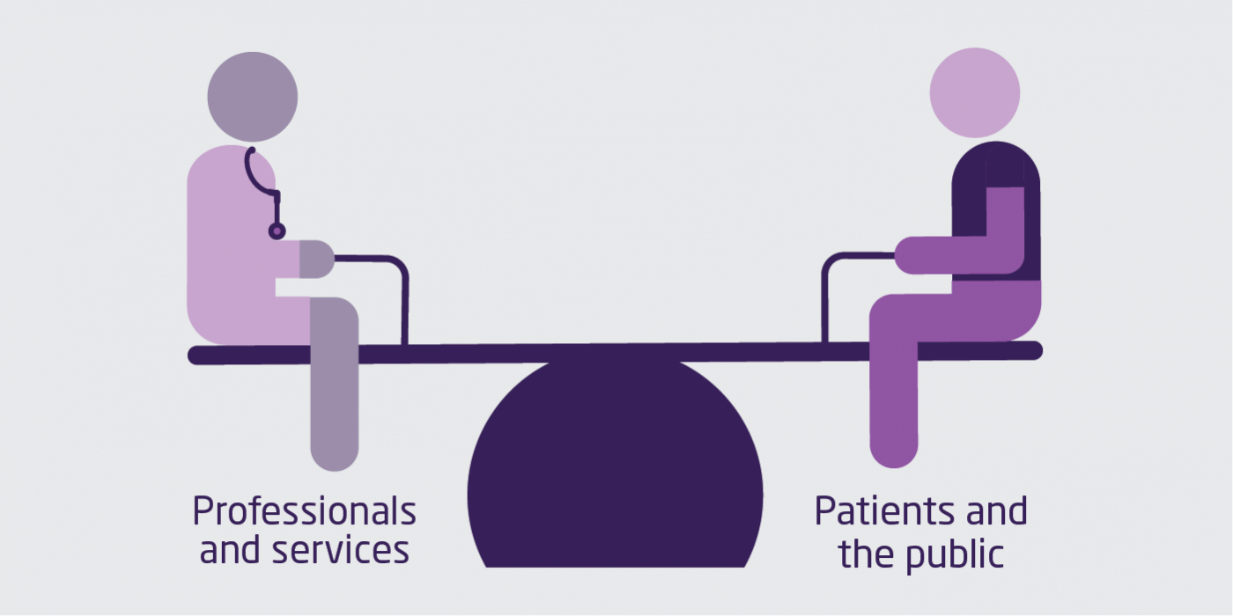
The plan includes a commitment to increasing support for people to manage their own health and highlights the need to create genuine partnerships between professionals and patients.
As part of this shift, the plan focuses on personalisation. There is a commitment to rolling out the NHS comprehensive model of personalised care (which brings together 6 programmes aimed at supporting a whole population, person-centred approach), so that it reaches 2.5 million people by 2023/24, with an ambition to double that figure within a decade. Referrals to social prescribing schemes will increase, broadening the range of support available, and the roll-out of personal health budgets will be accelerated, so that these are in place for up to 200,000 people by 2023/24.
The plan also includes a welcome focus on supporting carers. This includes introducing quality markers for primary care, highlighting best practice in identifying carers and providing them with appropriate support. It also encourages the national roll-out of carer’s passports, which enable staff to identify someone as a carer and involve them in the patient’s care and promises a more proactive approach to supporting young carers.

The King's Fund's view
These actions signal a welcome move away from one-size-fits-all approaches towards more tailored support for individuals based on what matters to them. As the plan acknowledges, this cannot be done in isolation and the NHS will need to work closely with partners, especially local government and the voluntary sector. The training for professionals is a significant step forward and should draw on the expertise of patient leaders. Work in this area should encourage bottom-up approaches that empower staff and connect the service with communities. The welcome focus on shared responsibility, rather than personal responsibility, needs to be accompanied by a renewed focus on supporting people to make healthy choices and more government action through taxation and regulation, as well as wider action on the social determinants of health. While the plan includes several commitments aimed at involving people in their own care, it says disappointingly little about patient and public engagement in shaping health services or the role of communities in health.

Integrated care and population health
The plan confirms the shift towards integrated care and place-based systems which has been a defining feature of recent NHS policy. ICSs will be the main mechanism for achieving this – the plan says that ICSs will cover all areas of England by April 2021 – and will increasingly focus on population health.
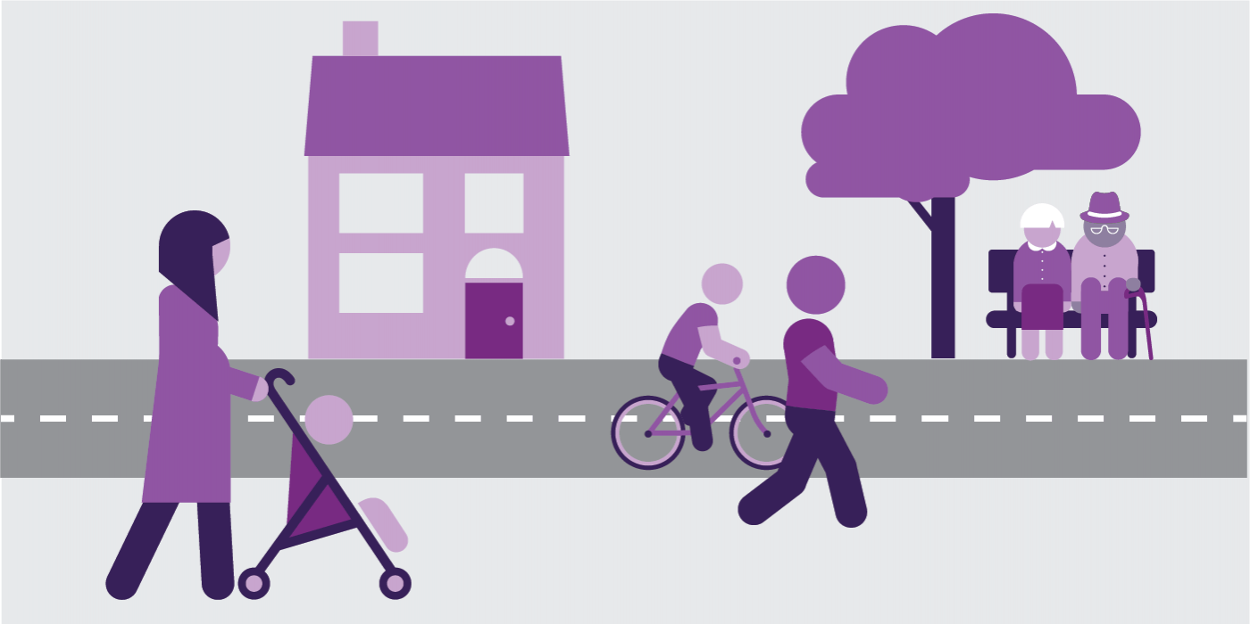
The plan confirms the shift towards integrated care and place-based systems, with an increasing focus on population health.
The plan outlines several core requirements for ICSs (such as the establishment of a partnership board comprising representatives from across the system) but stops short of setting out a detailed blueprint for their size or structure. Systems will be required to ‘streamline’ commissioning arrangements, which will ‘typically involve’ a single CCG across each ICS. It also recognises that NHS organisations will need to work in partnership with local authorities, the voluntary sector and other local partners to improve population health.
From 2019, population health management tools will be rolled out, enabling ICSs to identify groups at risk of adverse health outcomes and inequalities and to plan services accordingly. ICSs will also be supported by changes to funding flows and performance frameworks. A new ICS accountability and performance framework will consolidate local performance measures and a new integration index will measure patient and public views about local service integration. Existing approaches to bringing together health and social care budgets are also encouraged, with an expectation that the social care Green Paper will set out further proposals. There will also be a review of the Better Care Fund.
The move towards a more interconnected NHS will be supported by a ‘duty to collaborate’ on providers and commissioners, while NHS England and NHS Improvement will continue efforts to streamline their functions. The plan suggests that progress can continue to be made within the current legislative framework but also puts forward a list of potential legislative changes that would accelerate progress, in response to requests from the Health and Social Care Select Committee and the government. The proposed changes include allowing joint decision-making between providers and commissioners and reducing the role of competition in the NHS.

The King's Fund's view
Taken together, these commitments signal a welcome continuation of the direction of travel set out in the Forward View, with ICSs playing an increasingly important role in planning and managing services. National NHS bodies have not been overly prescriptive and the plan leaves welcome flexibility for local sensitivity in implementing ICSs, as well as commitments to support areas that are further behind. While the plan stops short of providing the comprehensive vision for population health we have argued for and the role of local authorities is underplayed, the increasing focus on population health is welcome. To avoid the difficulties associated with STPs, ICSs will need to prioritise engagement with local partners, including local authorities and the voluntary sector, and involve patients and communities. With changes to legislation unlikely to take place in the short term, the immediate priority for ICSs will be to continue making as much progress as possible within the existing legislative framework.

Prevention and health inequalities
The plan signals a clear focus on prevention, recognising that the NHS can take important action to ‘complement’ – but not replace – the role of local authorities and the contribution of government, communities, industry and individuals. A ‘renewed’ NHS prevention programme will focus on maximising the role of the NHS in influencing behaviour change, guided by the top five risk factors identified by the Global burden of disease study: smoking, poor diet, high blood pressure, obesity, and alcohol and drug use.
Commitments include the provision of alcohol care teams in a quarter of hospitals with the highest rate of alcohol dependence-related admissions, and a promise that by 2023/24, NHS-funded tobacco treatment services will be offered to all smokers admitted to hospital. There are also plans to introduce new programmes for specific diseases and conditions, and to scale up existing ones. For example, the number of places on the Diabetes Prevention Programme will double over the next five years. Acknowledging the contribution the NHS can make to action on air pollution, the plan also commits to reducing the mileage and air pollutant emissions from the NHS fleet by 20 per cent by 2023/24.
ICSs will have a key role in helping to deliver these programmes and in working with local authorities, the voluntary sector and other local partners to improve population health and tackle the wider determinants of ill health. Significantly, the plan indicates that the NHS and government will consider whether the NHS should have a ‘stronger role’ in commissioning sexual health services, health visitors and school nurses (currently commissioned by local government). Spending in these areas is not covered by the plan as it is routed through local authorities.

Health inequalities
The plan commits to a ‘more concerted and systematic approach to reducing health inequalities’, with a promise that action on inequalities will be central to everything that the NHS does. To support this ambition and to ensure that local plans and national programmes are focused on reducing inequalities, specific, measurable goals will be set. Local areas will need to set out how they will achieve this, drawing on a menu of evidence-based interventions developed by NHS England, Public Health England and others. Changes to commissioning allocations for CCGs will ensure that a higher share of funding is targeted at areas with high inequalities and a review of the inequalities adjustment to funding formulae will be undertaken.
The plan includes specific goals for particular groups – for example, greater continuity of midwife care for black, Asian and minority ethnic women and women from deprived groups; an increase in physical health checks for people with severe mental health. The plan also identifies £30 million worth of investment in meeting the needs of rough sleepers and ensuring better access to specialist mental health support.

The King's Fund's view
The focus on prevention is welcome, although the challenge will be to turn rhetoric into reality, given the poor track record of following through on previous good intentions. In addition to the key role the NHS has to play, progress will depend on action from local and central government. The first test of this will come with the Spending Review, and whether the government reverses the damaging cuts made to the public health budget. While the new prevention initiatives are welcome, the focus on single diseases and behaviours fails to recognise that health conditions (in the form of multi-morbidities) and unhealthy behaviours tend to cluster together and are closely linked to health inequalities. The plan pushes health inequalities firmly up the agenda. The commitment to establishing specific goals for reducing inequalities, which focus on the NHS’s role in this, is particularly welcome. Broader progress on health inequalities will again depend on wider government action and the strength of local partnership-working.

Implementation
Further detail on how the commitments in the long-term plan will be implemented will be set out in a national implementation framework, due to be published in spring 2019. However, there are a number of other plans and reviews will have an impact on how the plan is implemented. These include the following:
- a clinical review of standards setting out expectations on operational performance, including a review of waiting time targets, due to be published in spring 2019
- a workforce implementation plan, overseen by a cross-sector national workforce group, due to be published later in 2019
- a review of the Better Care Fund, due to be completed in early 2019.
The Spending Review will outline funding for areas of NHS spending not covered by the plan such as workforce training and capital investment, as well as for social care and local authority-funded public health services. The social care Green Paper is expected to set out options for social care funding and proposals for health and social care integration. The prevention Green Paper, also expected in 2019, will focus on delivering the vision for prevention published in November 2018.
The plan is intended to provide a ‘framework for local planning’ over the next five years. Local areas have received indicative financial allocations for 2019/20 to 2023/24 and, in the short term, will be expected to develop plans for implementing the long-term plan’s commitments in 2019/20, a transitional year, as well as developing five-year system plans by the autumn. These plans will be ‘brought together in a detailed national implementation programme’ in the autumn of 2019.

Reflecting on the plan
Overall, the long-term plan amounts to an ambitious set of commitments within the constraints of the funding available. It is firmly focused on the future, rather than simply shoring up current models of care, and sets the right direction for the NHS by focusing on delivering joined-up, personalised, preventive care, and expanding primary and community services.

The plan signals both evolution and revolution
In many respects, the plan signals continuity rather than change. The focus on ICSs and expanding new models of care builds on the agenda set by the Forward View. Many of the chosen clinical priorities, including mental health and primary and community services, have also been singled out for attention in recent years. This reflects a constancy of purpose that has often been missing in health policy and should allow the NHS to build on recent progress.
Although the level of detail in the plan is variable, it differs from the Forward View by focusing more on delivery and implementation. There are measures to accelerate progress towards integrated care, for example by aligning regulation and providing funding for primary and community care. It signals a shift in gear from the bottom-up, iterative approach that followed the Forward View, while retaining a balance between national prescription and local autonomy. However, there is now no doubt that the NHS is moving rapidly away from the focus on organisational autonomy and competition that characterised the Lansley reforms.
There are some notable omissions from the plan. Multi-morbidity is barely mentioned despite the growing number of people living with multiple long-term conditions. In contrast to the Forward View, the plan is relatively silent on how the NHS will work with communities and engage patients and the public in shaping services. Also significant is the absence of any commitments to current waiting time targets - these are on hold until the clinical review of standards is published later in the year.

If delivered, the plan could make a positive difference to patients
The ambition to deliver more personalised, joined-up and proactive care – if it can be delivered – could make a significant difference to patients and change how they interact with health services. Potential benefits include: fewer handoffs and referrals for patients receiving care in the community; more NHS support for people in care homes; better access to services spanning mental health, general practice and community crisis response teams; fewer trips to outpatient appointments; more services and information available online; and more opportunities for people to make decisions about their own care.
By assuming that demand for acute services will continue to increase at roughly its current rate, the plan provides a welcome dose of realism and avoids the mistake made in predecessor plans of assuming that strengthening primary and community services will result in reduced demand for hospital care. Changes to acute services include significant reforms to urgent and emergency care, a major overhaul of outpatient services, more hospitals splitting services between hot and cold sites, further consolidation of stroke services and possible changes to service configurations if more hospitals take up the green light to merge. Taken together, this adds up to an ambitious agenda for change that could provide significant benefits for patients. Delivering it will require skilful leadership and a concerted effort to involve patients and communities.

The plan seeks to balance national direction and local autonomy
A consistent lesson from previous attempts at NHS reform is that central directives on their own often fail to deliver the improvements envisaged. To overcome this, the approach to delivering the plan balances national direction with local autonomy. National expectations are made clear and local systems will be accountable for contributing to national programmes on a ‘comply or explain basis’. At the same time, the plan promises that local implementation will be led by clinicians and leaders who are directly accountable for patient care.
This means that much is riding on the ability of local systems to deliver. ICSs are singled out as being central to the delivery of the plan. However, their development is currently much more advanced in some areas than others, and even the most advanced systems are in their early stages. ICSs have no formal powers or accountabilities (the plan does not suggest any change to this) and progress is dependent on the willingness of individuals and strength of local relationships. There are also high expectations on primary care networks as the key mechanism for delivering the expansion in primary and community services outlined in the plan. However, these are a long way from existing in the form or on the scale envisaged. Providing support for ICSs and primary care networks and building local leadership capacity and capability should therefore be key priorities.
National bodies have an important role in removing barriers to local implementation. This is recognised in the plan and reflected, for example, in the commitment to align regulation through a new ‘shared operating model’ across NHS England and NHS Improvement, and the emphasis placed on the performance of systems as well as organisations. This will also need to be reflected in the behaviours of regulators on the ground. The potential changes to the legislative framework also seek to remove barriers and accelerate change but the prospect of parliament passing new legislation remains unlikely in the short term. In the meantime, the plan is right to stress that the immediate priority is to continue making progress within existing legislation.

This is the NHS’s plan but the NHS does not operate in isolation
NHS leaders have done what was asked of them by delivering a forward-thinking plan that sets out how the NHS will spend the additional money promised by the government. It is essential to view the plan within this context, and to recognise its limitations. Critical interdependencies exist between the NHS and local government, wider public services and communities. A plan for the NHS cannot fully address this wider context, particularly when there is so much uncertainty about the future of social care and public health budgets are being cut.
The decision to delay publication of the social care Green Paper is a missed opportunity to tackle the issues facing and health and social care in a joined-up way. Delivery on many of the plan’s flagship commitments will depend on closer integration between health and social care, but the plan says relatively little about how NHS bodies and local authorities will work together to achieve this. The plan highlights the importance of a well-functioning social care system and notes the government’s commitment to ensure that decisions about social care funding do not impose any additional pressure on the NHS. However, the funding settlement for social care will not be known until the Spending Review later this year.
The commitment of the NHS to play its part in improving prevention and reducing health inequalities should be applauded but these aims cannot be achieved by the NHS in isolation. Partnerships between the NHS and local government will be key to delivering improvements in population health. ICSs should ensure that local authorities are equal partners and engage with the voluntary sector, patients and communities. Central government must also play its part by following through on the recent vision for prevention and using the forthcoming Green Paper on prevention to set out an ambitious agenda for improving the population’s health. This should include reversing cuts to public health budgets and being bolder about using other mechanisms at their disposal including tax and regulation to drive improvements in population health.

From planning to delivery
The long-term plan marks a significant step forward in setting the NHS on a sustainable course for the next decade. The main challenge will be to translate this into delivery. Even with exceptional leadership and the continued commitment of staff, delivering the extensive list of commitments outlined in the plan is a daunting task.
While the funding settlement is a significant improvement on the constraints of recent years, it is not a panacea. The NHS will continue to face tough choices about how to prioritise resources. One of the most important of these decisions – what to do about recovering waiting times standards – has been postponed. Patients are likely to continue to face longer waits for treatment for the foreseeable future.
The greatest risk to delivery is workforce shortages. Put simply, the NHS will not be able to achieve its ambitions if it does not have the number and type of staff that it needs. Much is now riding on the workforce implementation plan due later this year. While the long-term plan is an important piece of the jigsaw, the picture is far from complete.
With thanks to the policy leads and other colleagues for their contribution to this explainer.
Taken from https://www.kingsfund.org.uk/publications/nhs-long-term-plan-explained

